CHELMARSH PARISH COUNCIL
Clerk: Mrs Freda Morris
18 Glebe Drive
Stottesdon
Kidderminster
DY14 8UF
Tele: 01746 718453
Email: chelmarshpc@btinternet.com
Website: www.chelmarshpc.co.uk

The Annual Parish meeting will be held on Tuesday 23rd May 2023 at 7.00pm in Chelmarsh Parish Hall. This will be followed by the Annual Parish Council meeting – see separate agenda.
Local Government electors for the Parish will be entitled to vote at the meeting which will be open to the public (LGA 1972, ss13(1) and 32 (1)

Agenda:

01. Apologies
02. Minutes of last meeting 17th May 2022
03. Chairman’s Annual report
04. Shropshire Councillor’s report
05. Organisation reports:
a) Cricket Club
b) Bowling Club
c) Parish Hall
d) Jubilee Club
e) Chelmarsh PCC
f) Chelmarsh Friends Club
06. Parish problems
07. Chairman’s closing comments
08. Date of next meeting – 27th June 2023

Yours sincerely

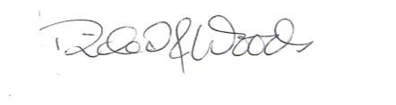
Richard Woods
Chairman

