Meeting Open to the Public
Will be held on
Wednesday 21st November 2018
7.30pm
In
Chelmarsh Parish Hall
A presentation of the plans for The Astbury will be given by Mr John Steven, Consultant to FCFM Group

Everyone welcome to attend

To view the planning applications online please follow the link on our website – www.chelmarshpc.co.uk
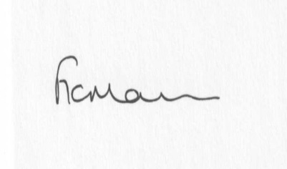
Freda Morris
Clerk to Chelmarsh Parish Council
01746 718453

